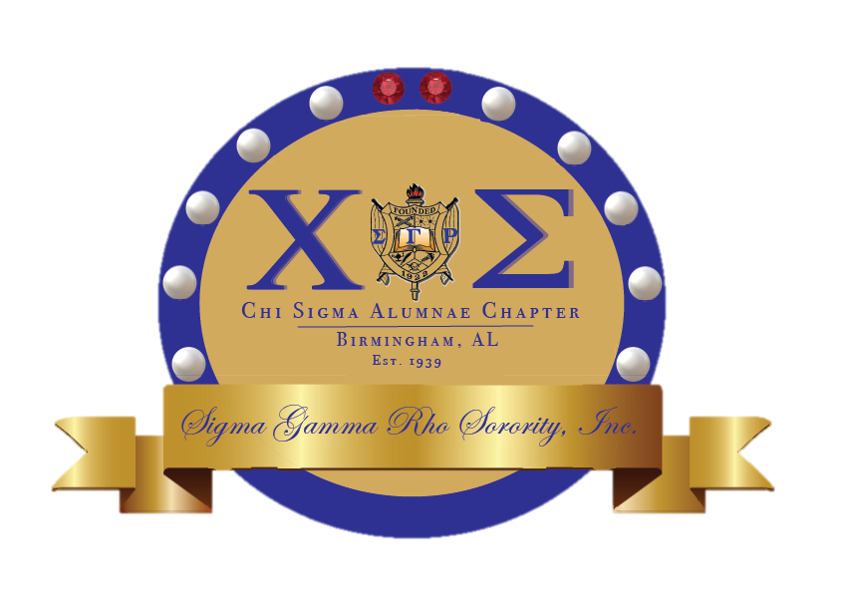

Chi Sigma

Chronicles

ccc



Event Details: Saturday October 17,2020

Event Name: Chi Sigma Pink Pumpkin Contest

Event Details: Submission Due Oct 19th 2020

Southeastern Region

Area meeting

Event Name: Chi Sigma Virtual Dinner

As Be The Match continues its partnership with Sigma Gamma Rho Sorority Inc. A campaign is being launched to increase the number of African American donors to the list. The Southeastern Region has been tasked with adding 200 new donors to the list. It is as simple as filling out the form, receiving the kit and returning it at no cost to you. To find out more information or to sign up to be a donor please visit:

join.bethematch.org/SGRhose

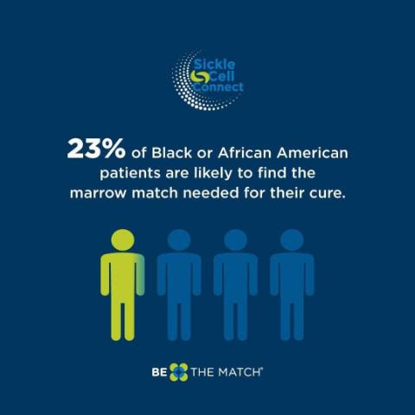

Be The Match

Upcoming Events

On October 3rd, 2020 Alabama/South Carolina Area meeting was held virtually and it was packed with so much information! In case you missed it here are some highlights to remember for the sorority year.

* No In-Person meeting until December 31,2020
* Registration for Centennial drops January 2021
* Chi Sigma will host Area Meeting in 2023
* The organization is bi-partisan due to its 501(c) status- Please be mindful of endorsing candidates while wearing paraphernalia.

Congratulations Soror L. Samuels!

As you all know we are well into voter registration season and Sigma Gamma Rho Sorority Inc are taking part in this campaign. The Southeastern Region has been asked to register 250 new voters with a national goal of 1000. However, our regional goal is 400. We are asking all Sorors to participate by utilizing this link <https://www.weallvote.org/sgrho/>. Let’s do our part to increase voter registration and participation.

Register to vote here: <https://www.sos.alabama.gov/alabama-votes/voter/register-to-vote>

Mail In Voting: <https://www.sos.alabama.gov/alabama-votes/voter/absentee-voting>



Congratulations to Soror L. Samuels on graduating with her BS in Business Administration /Human Resource Management! Soror Samuels is not stopping there and is pursuing here Masters in Public Administration as well! Congratulations again and much success on your continued journey!

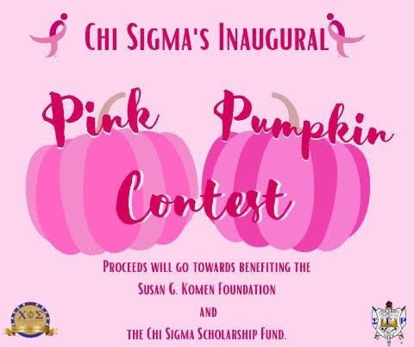

Congratulations Soror Jackson!

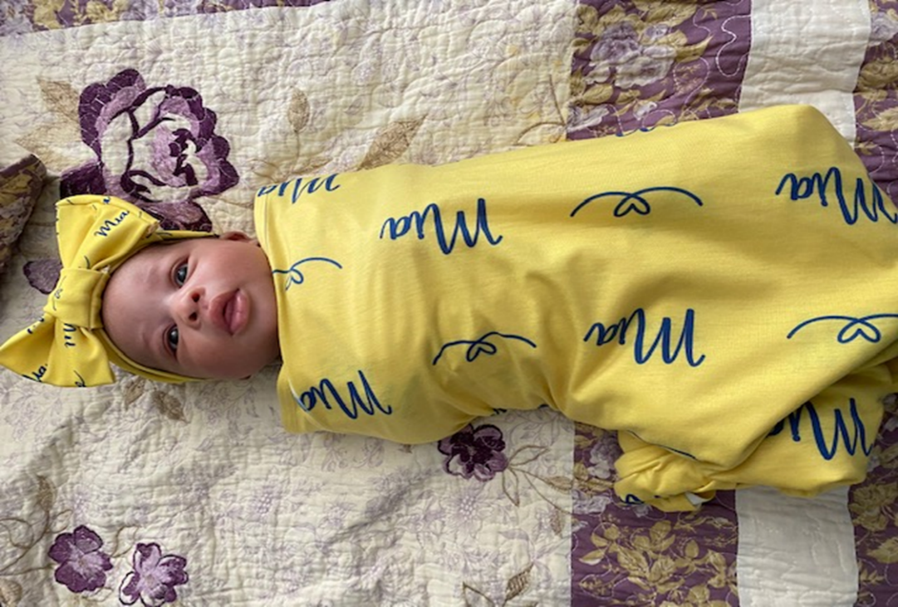

Congratulations are in order for Soror Jackson on the birth of Baby Mia! Baby Mia arrived on 9/24/2020!

Soror Jackson has requested that her photo is not posted on social media however she wanted to let the chapter know!

She is beautiful!



SIGMA FUN FACT

 Sigma Gamma Rho and Omega Psi Phi Power Couple. Selena Sloan Butler (1872–1964) (SGRHO) is the founder and first president of the National Congress of Colored Parents and Teachers Association (NCCPT). President Herbert Hoover appointed her to the White House Conference on Child Health and Protection in 1929. During World War II, she organized the Red Cross' first black women's chapter of "Gray Ladies." When Congress merged the NCCPT with the National PTA in 1970, Butler was posthumously recognized as one of the organization's founders. Today, Butler is considered a co-founder of the National Parent-Teacher Association. She attended a missionary-operated elementary school in Thomas County and studied at Spelman Seminary (later Spelman College). At the age of sixteen Butler graduated from Spelman in 1888 (with a high school diploma) and began her teaching career in Atlanta. She later became a member of the Eta Sigma chapter of Sigma Gamma Rho sorority. She married Henry Rutherford Butler,(Omega) a prominent African American doctor in Atlanta who had studied medicine at Harvard University in Cambridge, Massachusetts. The couple had one son, Henry Jr. As their son, Henry, Jr., approached school age, Selena looked for a preschool. Finding none in her neighborhood or in any black neighborhood in the city, she decided to start a kindergarten in her home. Henry Rutherford Butler, (Omega Psi Phi) a respected physician and pharmacist with offices on Auburn Avenue in Atlanta, was a pioneer in medicine and healthcare for African Americans during the late nineteenth and early twentieth centuries. He was married to Selena Sloan Butler, a prominent teacher and education advocate in Atlanta. In addition to establishing the first licensed black-owned pharmacy in Georgia, Butler was a founding member of several African American physicians' organizations, as well as a civic leader and prolific writer. In many ways, his life represents the historical yet paradoxical development of a southern urban African American elite class between the eras of Reconstruction and the modern civil rights movement, decades marked by widespread segregation and discrimination and in 1883 Butler entered Lincoln University in Pennsylvania. After graduating four years later, he continued his education at Meharry Medical College in Nashville, Tennessee, where he graduated with a medical degree in 1890. That same year, Butler moved to Atlanta, where he began his medical practice. In 1893 he married Selena Sloan, a native of Thomasville and a graduate of Spelman College. Henry Rutherford Butler Jr., the couple's only child, was born in 1899. Following in his father's footsteps, Butler Jr., a graduate of Atlanta University (later Clark Atlanta University) and Harvard University Medical School in Cambridge, Massachusetts, became a doctor and established a medical practice and family in Los Angeles, California. Among Butler's fraternal affiliations were Omega Psi Phi and Sigma Pi Phi fraternities and the Prince Hall Masons of Georgia. In the latter, Butler was the ninth grand master of the Most Worshipful Prince Hall Grand Lodge of Georgia from 1901 until his death in 1931,

October Birthdays!

Soror Studivant- October 10th

Soror Alexander-October 20th

Soror Ogletree- October 20th

Soror Miller- October 27th

\*\*\*Announcements\*\*\*

Please be sure to log in community service hours! An eblast was sent on 8/21/2020 outlining what can count .

Achieved an accomplishment or want something added to the newsletter? Email Soror Treadwell at chisigmaepistoleus@gmail.com

Birthdays/

Announcements